**CHAPTER 2**

**SYSTEM DESIGN**

## 2.1 SCHEMA DIAGRAM

A Schema is a pictorial representation of the relationship between the database tables in the database that is created. The database schema of a [database system](https://en.wikipedia.org/wiki/Database_system) is its structure described in a [formal language](https://en.wikipedia.org/wiki/Formal_language) supported by the [database management system](https://en.wikipedia.org/wiki/Database_management_system) (DBMS). The term "[schema](https://en.wiktionary.org/wiki/schema)" refers to the organization of data as a blueprint of how the database is constructed (divided into database tables in the case of [relational databases](https://en.wikipedia.org/wiki/Relational_databases)). The formal definition of a [database](https://en.wikipedia.org/wiki/Database) schema is a set of formulas (sentences) called constraints imposed on a database.

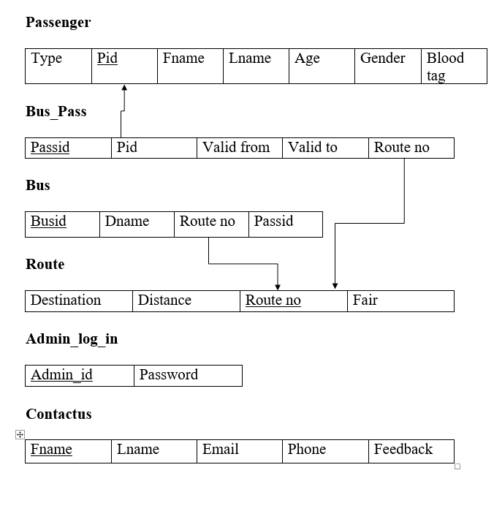

**Fig 2.1: Schema Diagram**

**CHAPTER 3**

**IMPLEMENTATION**

This chapter tells about the language used for implementation of the project and platform on which it was executed.

## LANGUAGE AND PLATFORM USED FOR IMPLEMENTATION

### Software Requirements:

* Operating System: windows
* Front end: php
* back end: MySQLi
* Web server: Apache
* Web browser: chrome, Mozilla

**3.1.1 XAMP: Application Server**

The full form of XAMP stands for Cross-platform, Apache, MariaDB(MySql), PHP and Perl. It is one of the simplest and light-weight local servers that is used to test your website locally. It is an open source platform. This includes X-OS because it works in all major operating systems like Windows, Linux, Mac etc. It includes features like Filezille, mercury mail, supporting Perl and much more. One of the main advantages is that you can perform as many testing and update the content in your website testing and update the content in your website testing locally. Since it is an open source, you can easily download and install in your system. You can perform a number of testing installing it once.

**3.1.2MySQLi**

The MySQLi Extension ([MySQL](https://en.wikipedia.org/wiki/MySQL) Improved) is a [relational database](https://en.wikipedia.org/wiki/Relational_database) driver used in the [PHP](https://en.wikipedia.org/wiki/PHP) [scripting language](https://en.wikipedia.org/wiki/Scripting_language) to provide an interface with [MySQL](https://en.wikipedia.org/wiki/MySQL) [databases](https://en.wikipedia.org/wiki/Database). The PHP code consists of a core, with optional extensions to the core functionality. PHP's MySQL-related extensions, such as the MySQLi extension, and the MySQL extension, are implemented using the PHP extension framework. An extension typically exposes an API to the PHP developer, to allow its facilities to be used programmatically.

**CHAPTER 4**

**RESULTS**

## 4.1 SNAPSHOTS

Home page has a link to admin to add student/faculty details .Student can login with their usn and can see their bus pass details.

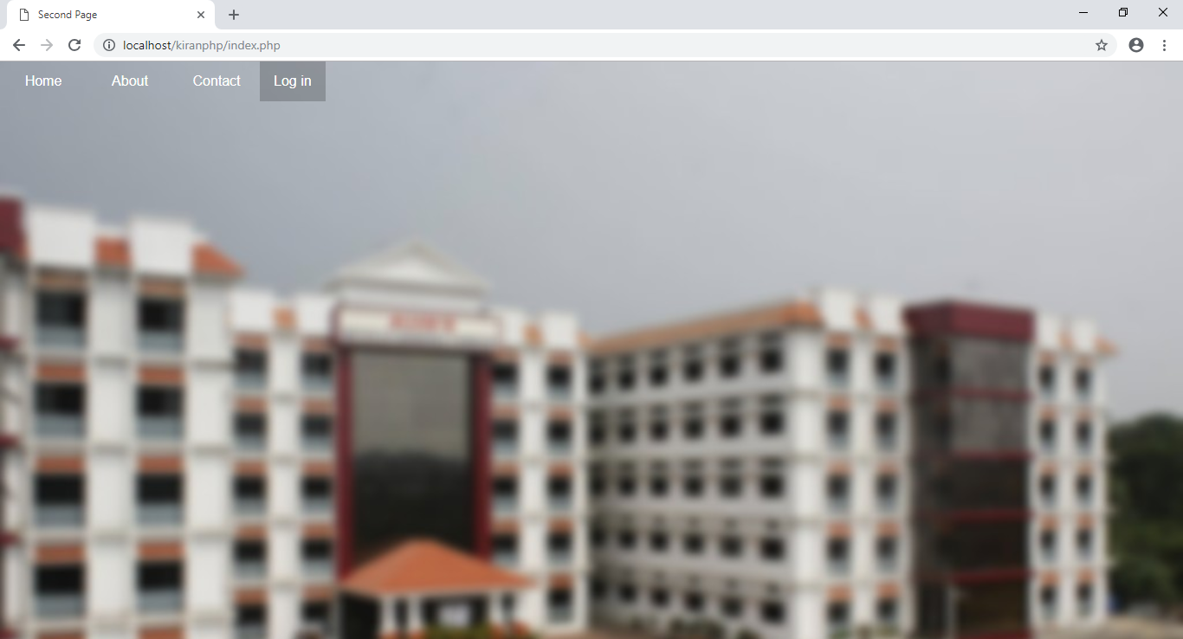

**Fig 4.1.1Home Page**

This is the First page i.e. the home page which the user encounters after any user opens the application.

**CHAPTER 5**

**CONCLUSION AND FUTURE ENHANCEMENT**

This chapter gives what exactly the project does and what is the future scope of the project

**5.1 CONCLUSION**

College Bus information system is software which will inform about the transport facility in college The College bus information application reduce the consumption of time during maintaining the records of college Transport management. Using this application we can avoid manual paper work which was done previously by transport management and it will also be easy to insert and update the student details.

**5.2 FUTURE ENHANCEMENT**

The introduced system can be improved by adding additional features such as payment of bus fee through online. All the information related to payment should be stored in database.